**Screenshot of Dashboard and Story**

Dashboard screenshot 1

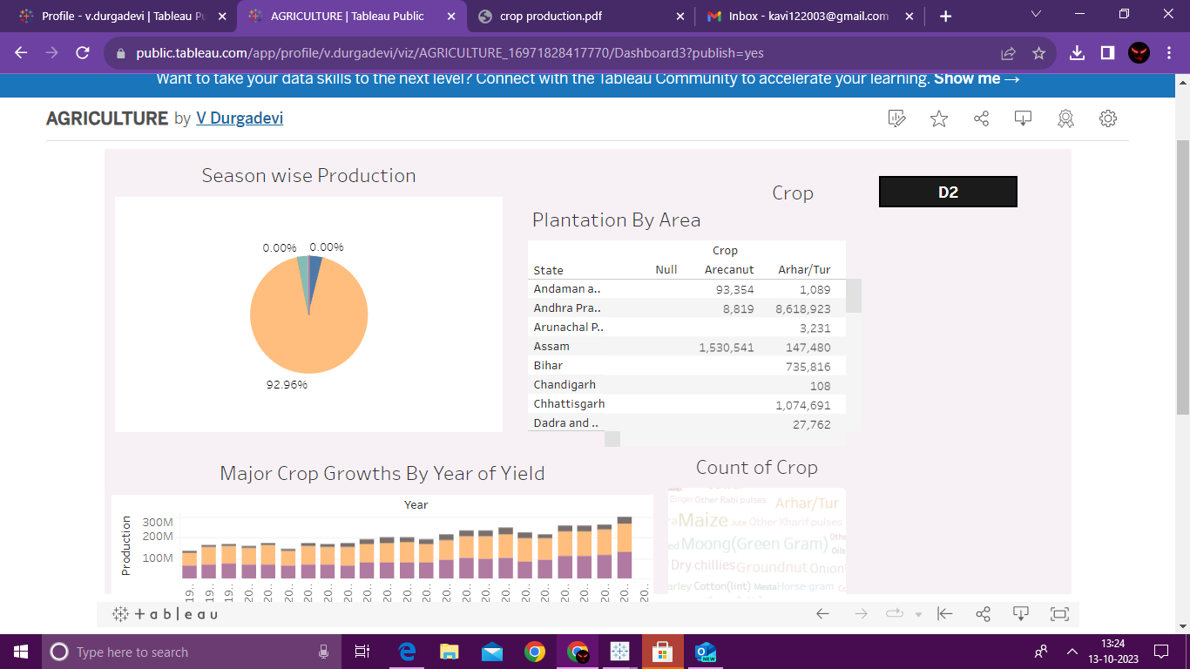

Dashboard screenshot 2

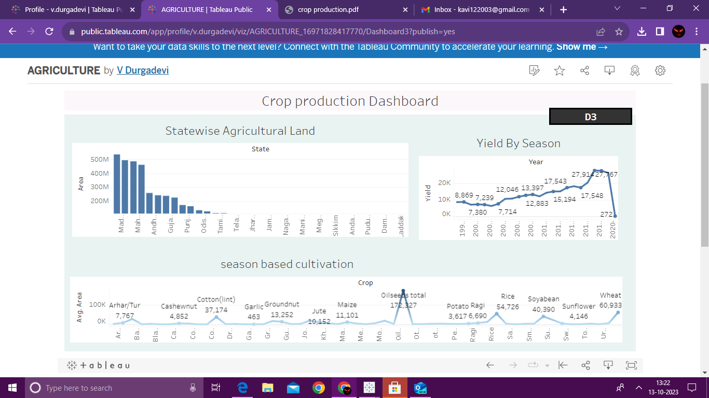

Story screenshot

